**Question1**

**Create a function that takes a string and returns a string in which each character is repeated once.**

**Examples**

**double_char("String") ➞ "SSttrriinngg"**

**double_char("Hello World!") ➞ "HHeelllloo WWoorrlldd!!"**

**double_char("1234!_ ") ➞ "11223344!!__ "**

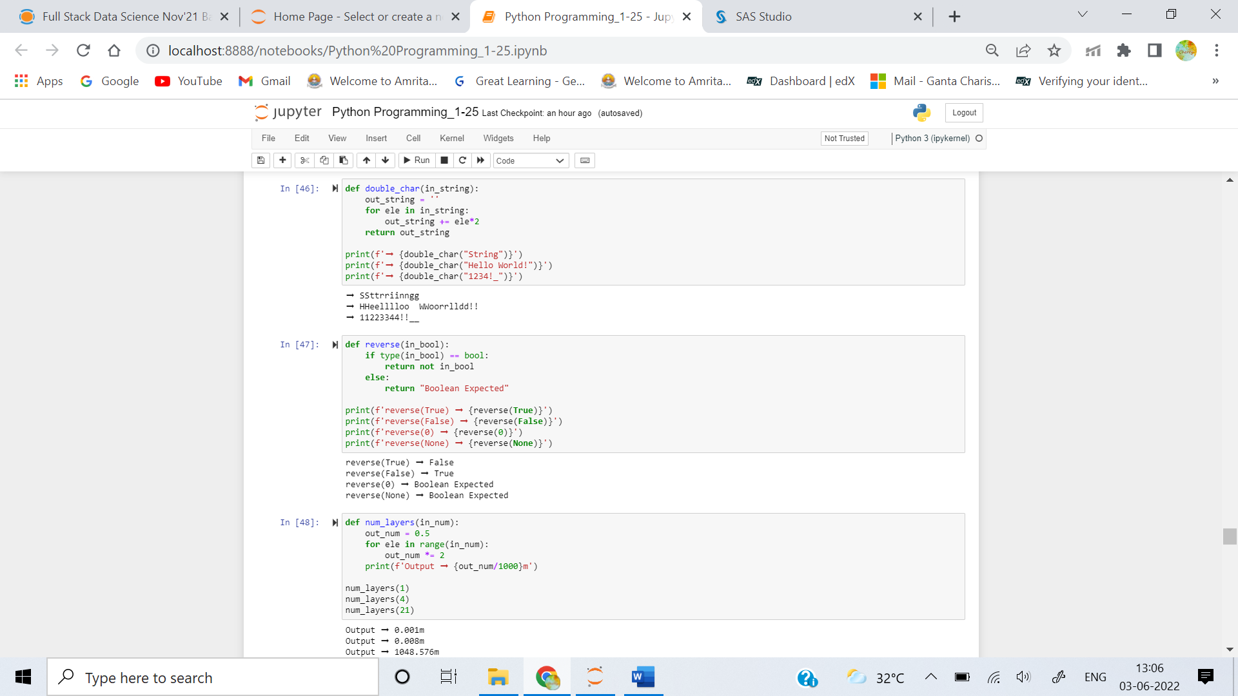

**Question2**

**Create a function that reverses a boolean value and returns the string "boolean expected" if another variable type is given.**

### Examples

**reverse(True) ➞ False**

**reverse(False) ➞ True**

**reverse(0) ➞ "boolean expected"**

**reverse(None) ➞ "boolean expected"**



**Question3**

**Create a function that returns the thickness (in meters) of a piece of paper after folding it n number of times. The paper starts off with a thickness of 0.5mm.**

### Examples

**num_layers(1) ➞ "0.001m"**

**# Paper folded once is 1mm (equal to 0.001m)**

**num_layers(4) ➞ "0.008m"**

**# Paper folded 4 times is 8mm (equal to 0.008m)**

**num_layers(21) ➞ "1048.576m"**

**# Paper folded 21 times is 1048576mm (equal to 1048.576m)**



**Question4**

**Create a function that takes a single string as argument and returns an ordered list containing the indices of all capital letters in the string.**

### Examples

**index_of_caps("eDaBiT") ➞ [1, 3, 5]**

**index_of_caps("eQuINoX") ➞ [1, 3, 4, 6]**

**index_of_caps("determine") ➞ []**

**index_of_caps("STRIKE") ➞ [0, 1, 2, 3, 4, 5]**

**index_of_caps("sUn") ➞ [1]**

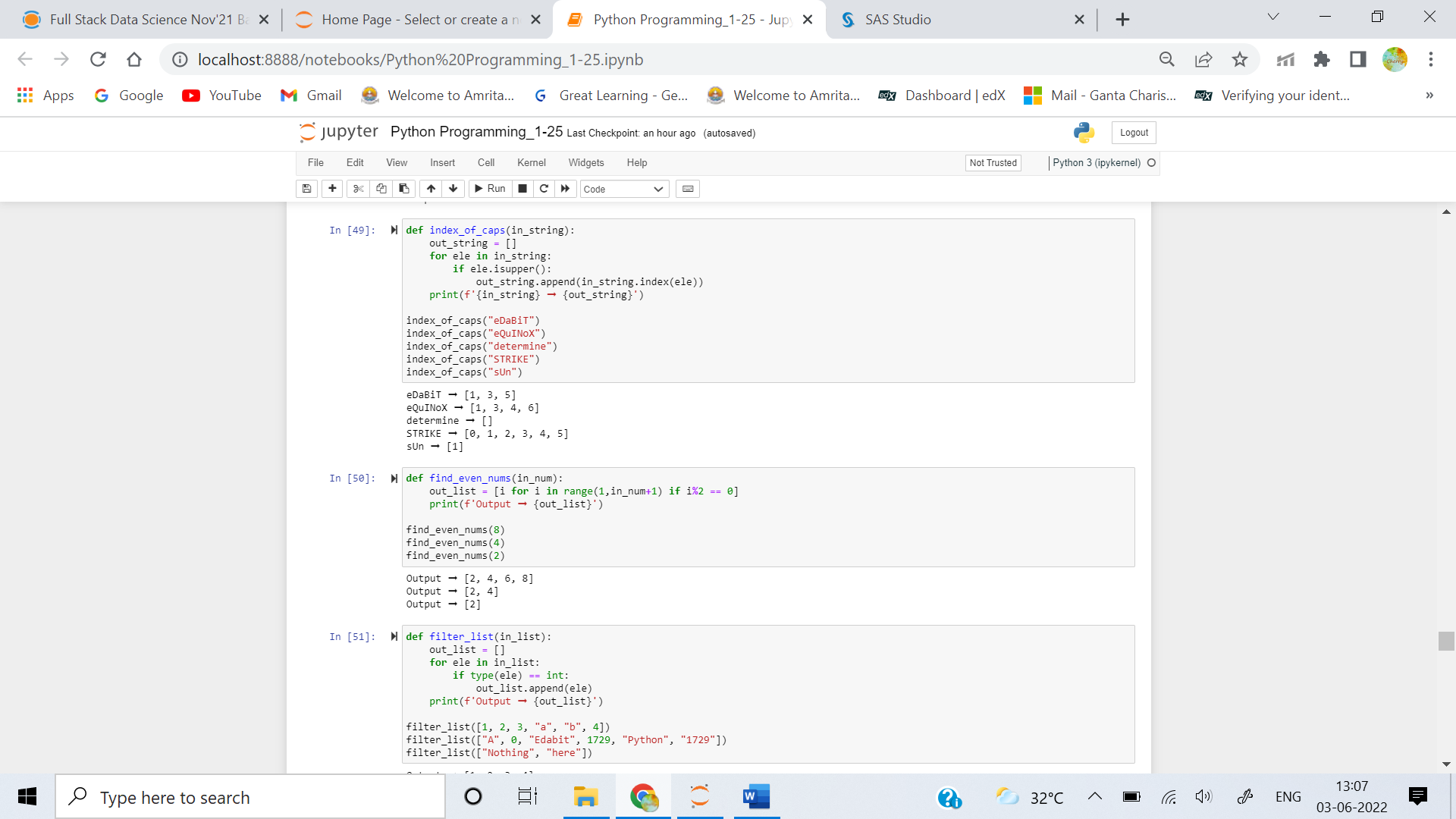

**Question5**

**Using list comprehensions, create a function that finds all even numbers from 1 to the given number.**

### Examples

**find_even_nums(8) ➞ [2, 4, 6, 8]**

**find_even_nums(4) ➞ [2, 4]**

**find_even_nums(2) ➞ [2]**

